Vijaykumar R Pai

PES1201702013

1. Created text file called sales.txt inside Pig folder

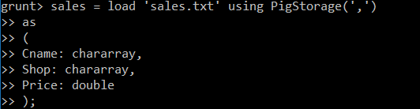

1. Dump sales;

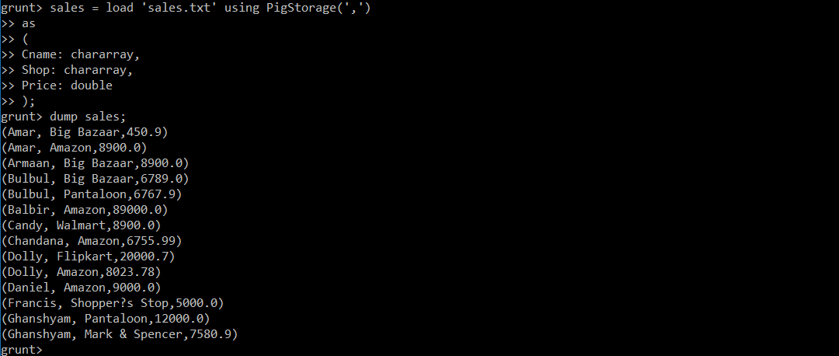

1. Describe sales;



1. sales_deptstore = foreach (GROUP sales by Shop) { Generate group, COUNT(sales.Name) as customer, (float)SUM(sales.Price) as sales_revenue;};

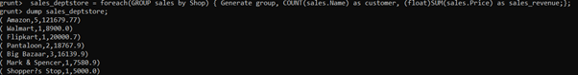

1. sales_customer = foreach (GROUP sales by Name) { Generate group, COUNT(sales.Name) as customer, (float)SUM(sales.Price) as sales_revenue;};

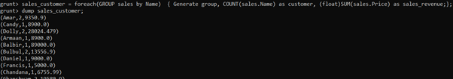

6) Shown in 8th question

7) Shown in 8th question

8) 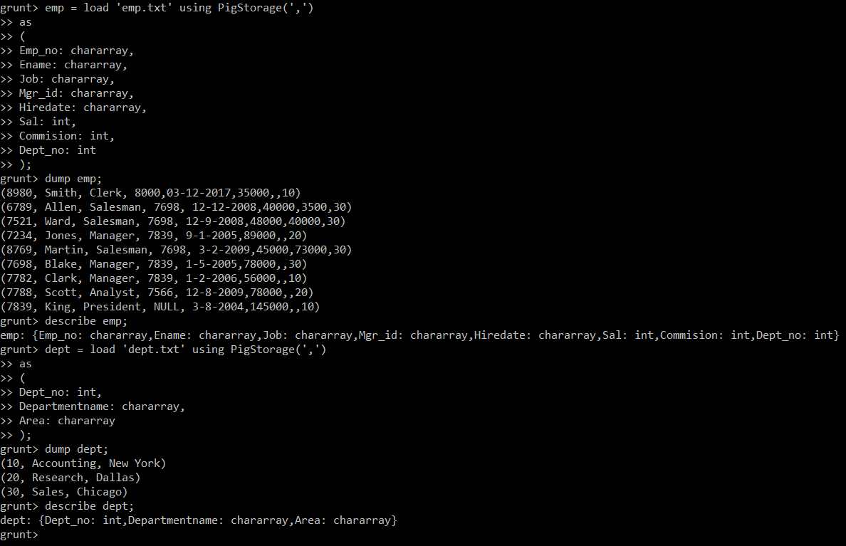

9) emp_sub = filter emp by Job == 'Manager';

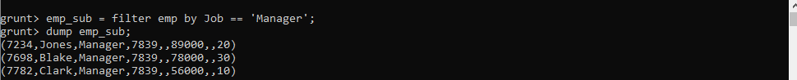

10) result = order emp by Dept_no ASC, Job DESC;

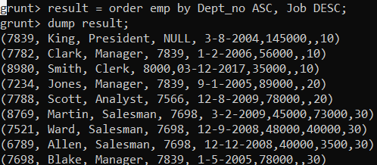

11) emp_sub = filter emp by Commision > Sal;



12) comm_null = filter emp by Commision is not null;

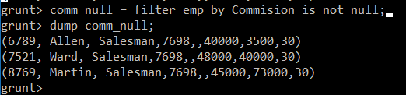

13) name_S_H = filter emp by (STARTSWITH(Ename, 'S')==true) AND (ENDSWITH(Ename, 'h')==true);



14)

15)